How Do Plants Grow?

Plant Cells and Processes

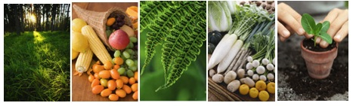
Middle School Unit: Student Pages

Environmental Literacy Project
http://edr1.educ.msu.edu/EnvironmentalLit/index.htm

Jennifer Doherty, Lindsey Mohan, Dante Cisterna, and Andy Anderson

April, 2010

Development of these materials is supported in part by grants from the National Science Foundation: Developing a Research-based Learning Progression for the Role of Carbon in Environmental Systems (REC 0529636), the Center for Curriculum Materials in Science (ESI-0227557), Learning Progression on Carbon-Transforming Processes in Socio-Ecological Systems (NSF 0815993), and Targeted Partnership: Culturally relevant ecology, learning progressions and environmental literacy (NSF-0832173). Any opinions, findings, and conclusions or recommendations expressed in this material are those of the author(s) and do not necessarily reflect the views of the National Science Foundation.

Name: __________________________________Period: ______ Date: ____________

Investigating Plant Growth

Plants can grow from tiny seeds into large trees, bushes, and flowers. Brainstorm with your group what you think a plant needs to grow.
_______________________________________________________________________
_______________________________________________________________________
_______________________________________________________________________

Today you will set up an experiment to test some of your ideas about what plants need to grow. Your group will grow seeds in four different experimental conditions and determine which conditions help the seeds grow best. You will set up the experiment today and monitor the growth of your seeds over the next week.

PLEASE KEEP THIS HANDOUT TO RECORD YOUR DATA!

The four experimental conditions you will use are:
  - light + water
  - light + dry
  - dark + water
  - dark + dry

Based on your ideas about what plants need to grow, what do you think will happen to the seeds in each of these conditions in 10-14 days? Record your group’s predictions in the table below:

Experimental Condition | Predictions
Experimental Condition | What will happen to seeds? | Will the weight of the seeds increase, decrease, or stay the same?
Light + water
Light + dry
Dark + water
Dark + dry

Material List:
4 Petri dishes
4 pieces of masking tape, 1 marker
80 radish seeds
~50 mL water
4 pieces of cheesecloth, 4 rubber bands
Scale (to weigh seeds); 1 paper cup or weigh boat
1-2 Paper towels (to pat dry some of the seeds)

Procedures for setting up your seeds after obtaining materials:
Step 1: Prepare containers: Label your 4 Petri dishes using the masking tape and marker. The labels will indicate your 4 experimental conditions. You might also write your group name on the tape so that your containers will not be confused with another group. Make the following labels:
1. light + water
2. light + dry
3. dark + water
4. dark + dry

Step 2: Weighing the Seeds: Divide the seeds into 4 equal piles (~20 seeds in each pile). It is important the groups be equal so you can compare among the four treatments at the end of the experiment. Place each group of seeds in a paper cup to calculate the exact weight of the seeds. Once you weigh each group, place them in one of the four Petri dishes and record the weight in Table 1. Make sure to record the correct weight for each group

Step 3: Watering Seeds for conditions 1 & 3: For the wet treatments (1 and 3), water the seeds thoroughly and allow them to soak for at least 5 minutes to absorb as much water as they can. Drain off excess water after the seeds have soaked using a paper towel to pat the seeds dry, but allow some water to remain on the seeds.

Step 4: Covering the containers: After you have soaked the 2 ‘wet’ treatments and weighed each of the 4 groups of seeds, they should be placed in the Petri dishes. Cover the 4 Petri dishes with a piece of cheesecloth. You will use a rubber band to keep the cloth securely fastened to the container.

Step 5: Placing the containers: Place the containers in the proper areas designated by your teacher. Treatments 1 and 2 will remain in a lighted area; treatments 3 and 4 will be placed in the dark.

Procedures for Maintaining Your Plants
Plants need to be checked daily to track progress and make sure that wet treatments remain moist throughout the experiment. However, you will only need to record observations of your seeds 2-3 times during the experiment using Table 2. Make sure to write complete and accurate descriptions of your seeds. Also be sure to write down what day you made your measurements.
Harvest your plants 10-14 days after planting

Step 1: Your teacher will provide paper “weighing envelopes” for you to put your harvested plant material in. Label the 4 envelopes with your group name and the 4 treatments (light+water, light+dry, dark+water, dark+dry).

Step 2: Carefully transfer all your plant material from the Petri dishes into the envelopes – check to be sure there are no seeds or seedlings clinging to the sides of the Petri dish or in the cheesecloth. Place your sample bags in the area indicated by your teacher. Your teacher will place them in a drying oven/dehydrator and allow them to dry completely (overnight).

Weighing your seeds again

After your plants have dried overnight, you will need to weigh the plant material. Weigh all four treatments. Make sure to weigh only the plants and not the bag too! Record the final weight in table 1. Calculate how much weight was gained or lost by the seeds/plants.

Table 1: Weight of seeds

 | Original weight of seeds | Weight of seeds or growing plants after 10-14 days | Difference in weight
Light & water

Light & dry

Dark & water

Dark & dry

Table 2: Observations of Seeds

 | Observations 1  Date: ______ | Observations 2  Date: ______ | Observations 3  Date: ______
Light & water

Light & dry

Dark & water

Dark & dry

Plant Growth: Data analysis questions

- What was required for radish seeds to sprout?
______________________________________________________________________
______________________________________________________________________

- What was required for radish seeds to gain mass? Why do you think that was?
______________________________________________________________________
______________________________________________________________________
______________________________________________________________________

- Where did the mass come from? How do you think this happened?
______________________________________________________________________
______________________________________________________________________
______________________________________________________________________

- Did any of your radish seeds lose mass? If so, where did the mass go? Why do you think this happened?
______________________________________________________________________
______________________________________________________________________
______________________________________________________________________
______________________________________________________________________
______________________________________________________________________
______________________________________________________________________

- Did the radish seeds grow in the dark? If so, explain where the seeds got their energy?
______________________________________________________________________
______________________________________________________________________
______________________________________________________________________
______________________________________________________________________

Name: __________________________________Period: ______ Date: ____________
Where does a plant’s mass come from?
A plant can grow from a tiny seed into a tree, bush, or flower. Where does this mass come from? When an animal gains weight, where does the extra mass come from? That’s right, food. The same is true for plants.
How do plants get food? What is food for plants? If we were to talk about food for humans, we would probably all talk about the same type of things – meat, fish, fruit, vegetables, grains, etc. However, although we might all have ideas about what plants need to grow and survive, we might be less clear on which of these things are considered food. In order to understand what food for plants is and how they get it, you need to remember the scientific meaning of the word “food:”
Food is material that contains chemical potential energy. Living things use the energy in food to live and grow.
There are two important parts to this definition:
1. Food is matter. What do humans, animals, plants and all other living things use the matter in food to do? _____________________________________________________
_______________________________________________________________________

2. Food stores energy (in the form of chemical potential energy). What kinds of things do humans, animals, plants and other living things use the energy in food to do?
_______________________________________________________________________
_______________________________________________________________________

3. The first thing we need to figure out is what can be considered as food for plants; that is, where do plants get energy and matter for growth? Put an X next to the things you think plants use as food.

_______ sunlight
_______ minerals
_______ water
_______ oxygen

_______ chlorophyll
_______ vitamins
_______ leaves

_______ carbon dioxide
_______ carbohydrates
_______ fertilizer (minerals and organic matter)
_______ soil (dirt and organic matter)

4. Explain your thinking when you answered #3. How did you decide if something on the list is food for plants?______________________________________________________
_______________________________________________________________________
_______________________________________________________________________

5. For each of the things you listed in your answer on the first page, which do you think could serve as a source of energy for plants? As matter for growth? If you think a substance provides both matter and energy, be sure to put it in both boxes.
Energy | Matter

Are soil and water food for plants?

Most people would say that plants need water and soil in order to grow, but they may not know what plants get from these things. We will consider several types of evidence in order to determine whether they can be considered food for plants.

Type of Evidence 1:
One of the first people who investigated this idea was a Belgian doctor named Jean Baptiste van Helmont who lived from 1577-1644. In addition to being a doctor, van Helmont did experiments with plants. In 1642, he did a famous experiment to test the idea of whether soil is food for plants.

1. Suppose a child was given a plate with 20 pounds of food to eat as quickly as they could. Predict what would happen to the weight of that child as he or she ate the food. Would the child’s weight go up, go down, or stay the same? What would happen to the weight of the food as the child ate it? Would the weight of the food go up, go down, or stay the same? Write your predictions in the table below.

Predict: Eventual weight of child | Predict: Eventual weight of food on plate
2. Now think about a young tree growing in a bucket of soil.
- Over time, will the tree’s weight go up, down, or stay the same?
- If soil is food for plants, would the weight of the soil go up, down, or stay the same?
- If soil is not food for plants, would the weight of the soil go up, down, or stay the same? Record your predictions in the table below.
Predict: Eventual weight of tree | Predict: Eventual weight of soil
 | If soil is food | If soil is not food

Von Helmont planted a 5-pound young tree in a bucket containing 200 pounds of soil. He watered the tree regularly but he did not add any more soil. After 5 years he weighed the tree and bucket again. Here are his results:
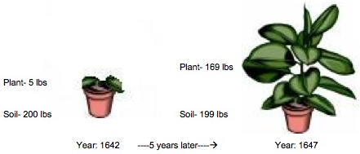
3. Look at the diagram of Von Helmont’s experiment. Can you figure out if the tree or soil lost or gained weight in the 5 years that the plant grew?
Weight Change of Tree | Weight Change of Soil

4. What does Von Helmont’s investigation tell you? Is soil food for plants? Why or why not?__________________________________________________________________________________________________________________________________________
Type of Evidence 2: Anything the U.S. Food and Drug Administration defines as food is required by law to have a nutritional label that provides information about the total calories; the amounts of fat, protein, and carbohydrate; and information about components known to impact health (e.g. saturated fats, cholesterol, fiber, calcium, and iron). In addition to labels on items that are considered food, the FDA also requires labels on things like vitamins and minerals that are considered “dietary supplements.”
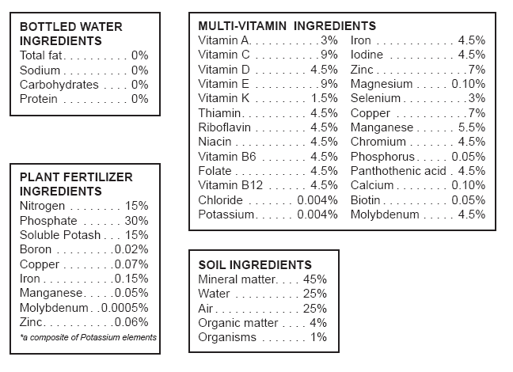
Using nutritional labels and other packaging information, you will compare the contents of food, water, dietary supplements, soil, and plant fertilizers (often casually called “plant food”). For your analysis, you will look at three factors: energy content (represented by calories), matter used as building blocks for growth (represented by fats, proteins, carbohydrates), and minerals (such as calcium, iron, magnesium, zinc, and manganese) that are important for optimizing cellular processes.

1. Examine the package labels from the items listed on the next page and use the information to fill out the data table. Record your answers as lots, little, none, or ND for “not determined.” Use what you know about human food for the last row.
Item | Provides useful energy | Contains building blocks for growth | Contains minerals
Water
Soil
Multi-vitamin with minerals
“Plant Food” or Fertilizer
Human Food
2. Water and “plant food” or fertilizer are two things that plants need in order to grow well. Based on your analysis, do either of these things fulfill the scientific definition of food? What is your evidence?
______________________________________________________________________________________________________________________________________________
_______________________________________________________________________

3. Compare the contents of plant food to those of human food and the multi-vitamin with minerals. Do products labeled “plant food” seem to be more like human food or more like a mineral supplement? What is your evidence?
______________________________________________________________________________________________________________________________________________
_______________________________________________________________________

4. Compare the typical composition of soil to food and the multi-vitamin with minerals. Does soil seem to be more like human food or more like a mineral supplement? What is your evidence?
______________________________________________________________________________________________________________________________________________
_______________________________________________________________________

5. What is the most likely function of soil and plant fertilizers in plant growth?
______________________________________________________________________________________________________________________________________________
_______________________________________________________________________

6. Could the tree live and grow if all it took in from the environment was water? Why or why not? _______________________________________________________________
_______________________________________________________________________
_______________________________________________________________________

Summary Questions
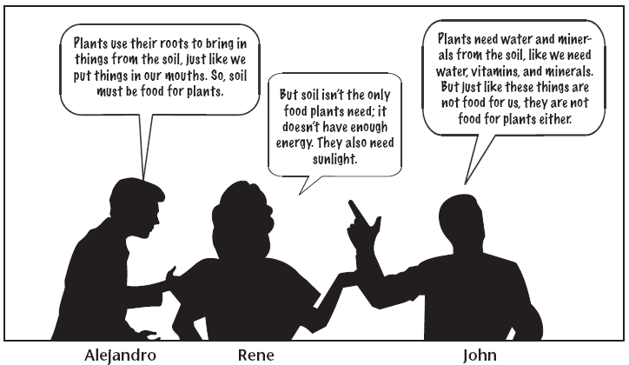
- Three friends are discussing how plants get energy to live and grow. Which student do you agree with? Explain your reasoning.
______________________________________________________________________________________________________________________________________________
_______________________________________________________________________

2. If water, soil minerals, and sunlight are not food for plants, what do you think is food for plants?
______________________________________________________________________________________________________________________________________________
_______________________________________________________________________

How do scientists find out if there are calories (chemical potential energy) in something?
One way to find out if something has chemical chemical energy is to burn it. If something has a lot of energy, then it will burn. Scientists burn various foods and measure how many calories are in them. This information can be put on our food containers so we know how many calories are in the food we are eating. We are going to burn some different materials and see if they have high or low amounts of energy.

 | Vitamin pill | Plant food | Sugar cube
Do you think it will burn?
Why?
Observations during demonstration
Does it have chemical energy?
Could it be food for plants?
(using the scientific definition)

In order to conclude whether the sugar cube, vitamin pill, and “plant food” stored chemical potential energy, what evidence did you use?
______________________________________________________________________________________________________________________________________________
_______________________________________________________________________

Name: ____________________________________________ Date: ______________
Zooming into plants
When we are walking in a place like a forest we can see many kinds of plants, like tall trees, shrubs and grasses and they all look different. However, if we look at this forest flying in a plane, we would not easily be able to tell the difference between different kinds.
1. While we are in the forest we are able to see different parts of the plants. Please name some plant parts that you know

Working with plant cards
2. In the chart write the numbers of the pictures according to their plant part.
ROOT | STEM/BRANCH | LEAF

3. In the chart, write the numbers of the pictures according to the closest scale.
TOO SMALL TO SEE WITH HUMAN EYE  (microscopic and smaller) | CAN SEE WITH OUR EYES  (macroscopic, visible) | TOO LARGE TO SEE WITH HUMAN EYE  (Landscape scale)

4. Though we can see the different plant parts, we can’t see what the parts are made of. If we could, what would we see?

5. You know that plants need some things in order to grow. Do their cells need these things too? Why do you think that?

What is photosynthesis?

What conditions in your radish experiment did your seeds need to gain mass? Does this mean that sunlight is food for plants? Remember, food is always matter that contains energy for living organisms. Water, soil, and minerals are things that plants need, but they are not food because they do not contain energy living things can use to live and grow. Sunlight is a kind of energy plants use, but sunlight is not food for plants because sunlight is a kind of energy, not matter. But sunlight does have something very important to do with food for plants. Scientists have found that plants are able to do something with the sun that humans or animals cannot do:

Plant can use the light energy of sunlight to make their own food in their leaves.

You can use a chemical test to see if a plant is making food. If you boil a leaf in ethanol to get rid of the green color, you can use iodine to stain the food the plant makes. If there is food being made, the leaf will turn purple. This test was used on radish seedlings just like yours. The figure below shows the radish seedlings made food in the light but not in the dark.
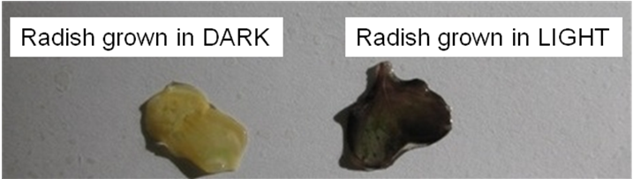
How do plants use sunlight?
In order to make energy-containing food, plants need two types of matter: water and carbon dioxide. Carbon dioxide is a gas that is in the air. Plants take in the water molecules from the soil. Water travels from the roots up tubes inside the plant. The water reaches the cells in the leaves. Carbon dioxide enters the leaves through tiny holes in the leaves.
The figure below shows the results of the iodine test again used on radish seedlings. This time both plants were grown in the light but one was covered in Vaseline so carbon dioxide could not get inside the leaf cells. Only the plant that had carbon dioxide from the air going into the leaf cells was able to make food.
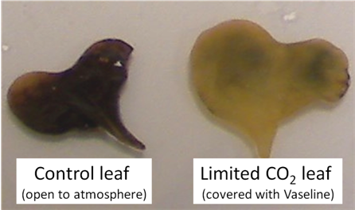
Inside the leaf cells of plants is a molecule called chlorophyll. Chlorophyll has the ability to capture the energy of sunlight. The light energy then breaks the bonds holding the atoms together in the water and carbon dioxide molecules. The atoms form new molecules of oxygen and a sugar called glucose, which the plant can use for good. In this process the light energy from the sun is changed (transformed) into chemical energy that’s stored in the glucose molecule.
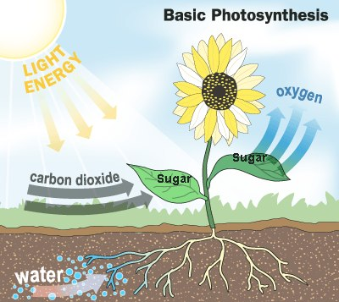
Photosynthesis
This process of making sugar is called photosynthesis. “Photo” means light and “synthesis” means putting together.
Photosynthesis makes only one kind of food: a sugar called glucose.

Sometimes scientists use equations to represent processes, such as photosynthesis.

A verbal equation for this change in matter is:

water and carbon dioxide turn into glucose and oxygen

The same equation written with the chemical symbols for the atoms:

6 H₂O + 6 CO₂ → C₆H₁₂O₆ + 6 O₂

As you can see from the equation above, glucose is composed of carbon, hydrogen, and oxygen atoms – the very same carbon, oxygen, and hydrogen atoms that were originally found in the carbon dioxide and water. However, the energy of sunlight (light energy) has been captured in the bonds between these atoms (chemical energy) in the glucose molecules.

The leaf cells can use the food they make, but the food can also travel from the leaves to all other parts of the plant. Getting food from leaf cells is the only way in the cells in the roots or stems or flowers can get the energy-containing food they need.

Plants use the glucose they make for two purposes. First, the glucose can be combined with other molecules that the plant has made or with minerals taken up from the soil to produce carbohydrates, fats, and proteins. The plant uses these carbohydrates, fats, and proteins to build cells in the roots, stems, leaves, flowers, and fruits. In this case, the plant is using the food as a source of matter. The second way that plants use the glucose they make is for energy. Cells can release the stored energy in food so it can be used to power cell functions. Plants can store food before using it for energy. When plants store food, they usually change it from glucose to some other kind of food, such as starch. All the food on earth started out as sugar made by plants!

Name: __________________________________Period: ______ Date: ____________
Plants make their own food

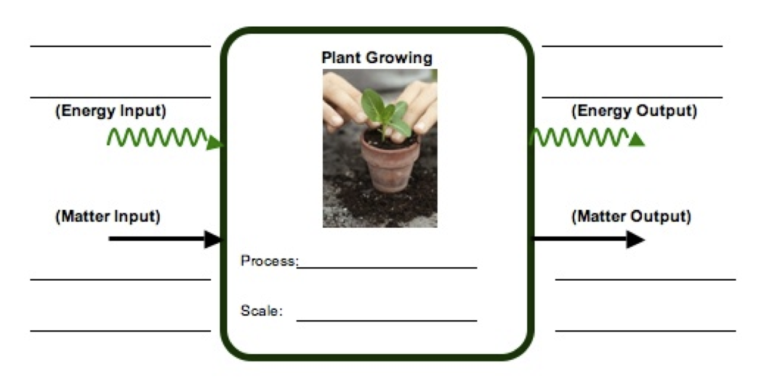
1. When plants make their food, they change matter and energy. Use the matter and energy process tool to show how plants change matter and energy.
Photosynthesis

Now try to use these ideas about how plants make food to explain the following situations:
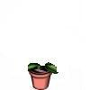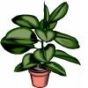
- Think about Von Helmont’s experiment: The tree gains 164 pounds after 5 years. Where did the weight of the tree come from? _______________________________
_________________________________________________________________________________________________________________________________________________________________________________________________________
- A drop of rain falls into the soil near the roots of a large plant. Describe what will happen to that water if it is taken into the plant. If it enters the roots, where will it travel, and what may happen to it? _______________________________________
_________________________________________________________________________________________________________________________________________________________________________________________________________

- Some plants were put in soil, given water, and placed in a tightly sealed bottle so they could not get any air. The bottle was placed in the sunlight. Will the plant in the jar be able to make food?______________________________________________
_________________________________________________________________________________________________________________________________________________________________________________________________________

Name: __________________________________Period: ______ Date: ____________

Modeling Photosynthesis

Recently you learned how plants make their own food from molecules of water and carbon dioxide using the energy from sunlight. Today you are going to model this food-making process, photosynthesis, in a potato plant.

- What benchmark scale can we use to classify a potato plant?

- What benchmark scale can we use to classify the leaf cells of a potato plant?

- On the potato plant poster, you can see that parts of the root, stem, potato, leaf, and fruit have been zoomed in on and drawn 100s of times bigger than they are. If we really wanted to see the leaf cells of a plant what kind of tool would we have to use?

- The cells of the potato plant have been zoomed in on even farther so you can show water, carbon dioxide, glucose and oxygen molecules moving around inside the plant. Could you see a molecule of glucose if you use a microscope to look inside a plant cell? Why or why not?

In your groups, you will use molecular model kits to model the process of photosynthesis. You will build the substances that go into cells, and then use the models to show how those substances change inside cells.
The chemical composition of glucose is C₆H₁₂O_{6.} This means that in one molecule of glucose there are:
6 atoms of carbon 12 atoms of hydrogen 6 atoms of oxygen

- Where do these atoms come from to make a molecule of glucose inside the plant?

- Carbon dioxide molecules contain 1 carbon atom and 2 oxygen atoms. How many carbon dioxide molecules (CO₂) does it take to make one molecule of glucose? (Hint: focus on how many carbon atoms you need to make a glucose) ______
CARBON DIOXIDE MOLECULE

- Carbon dioxide molecules look like the diagram on the right. Build 6 CO₂ molecules. Place them where they are before they enter the plant.

- Physically move the molecules to the leaves. Make sure to move the molecules to the atomic-molecular scale expansion of the leaf cell. Carbon dioxide gets into leaf cells through tiny holes in the leaf. Move the carbon dioxide molecules to the tiny hole and into a leaf cell.
WATER MOLECULE
- Water molecules contain 1 oxygen atom and 2 hydrogen atoms. How many water molecules (H₂O) does it take to make one molecule of glucose? (Hint: focus on how many hydrogen atoms you need to make a glucose) ______

- Water molecules look like the diagram on the right. Build 6 water molecules. Place them where they are before they enter the plant.

- Water gets into leaf cells by traveling from the roots, through the stem, and then into the leaf. The plant has special cells that act like tubes to move water quickly. They are blue on your poster. Move the water molecules from the soil and into the same leaf cell that has the carbon dioxide molecules.

- Look at the bonds in the water molecule. What type of bonds are they (i.e. C-C, C-H, C-O, H-O, or O=O)? Are they high energy or low energy bonds?

- Look at the bonds in the carbon dioxide molecules. What type of bonds are they? Are they high energy or low energy bonds?

Complete the table below summarizing the molecules you have just made:
 | Matter |  |  | Energy
 | # Carbon atoms | # Oxygen atoms | # Hydrogen atoms | High or Low Energy Bonds
Water
Carbon Dioxide
Total Atoms |  |  |  | LEAVE BLANK

- Using the information above, do you think either of these substances supply energy for plant cells to work?

- Using light energy, enzymes in a plant’s leaf cells combine carbon dioxide and water molecules to make glucose and oxygen molecules. First, you will break apart the carbon dioxide and water molecules and build a glucose molecule from the atoms. Then you will build oxygen.

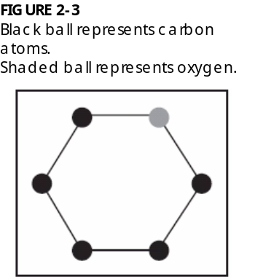
- Build a glucose molecule:

Step 1: Build the Glucose Ring. Look at the diagram to the right. This shows the first part of the glucose molecule. It shows 5 carbon atoms (black) and 1 oxygen atom (grey). This ring will start your glucose molecule

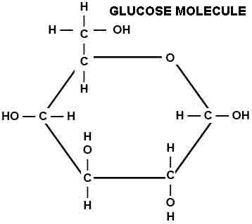
Step 2: Look at the diagram and circle on the right. You will work first with the carbon that is to the left of the oxygen in your ring. On this carbon, first connect a second carbon. On this second carbon, attach 2 hydrogen atoms and 1 oxygen. Attach another hydrogen to the oxygen. Then attach 1 hydrogen to the carbon that is on the ring. There should be no empty holes.

Step 3: Move to the next two carbons on the ring. Attach 1 oxygen and 1 hydrogen to these carbons. Then attach another hydrogen to each oxygen. Make sure it looks similar to the diagram to the right. There should be no empty holes on these atoms.

Step 4: Move to the last two carbons on the ring. Attach 1 oxygen and 1 hydrogen to these carbons. Then attach another hydrogen to each oxygen. Make sure it looks similar to the diagram to the right. There should be no empty holes on these atoms.

Check that there are no empty holes on your glucose molecules and that it looks like the diagram. Now you’re ready to build your oxygen molecules!

17. Build 6 oxygen molecules.

Step 5: With the remaining oxygen atoms, build 6 oxygen molecules. You should have 12 oxygen atoms left over, and this will make 6 oxygen molecules. Each molecule contains 2 oxygen atoms. These are bonded together twice (a double-bond). Build 6 oxygen molecules that look like the molecule on the right.

Once you have made your glucose and oxygen molecules, count the number of atoms in these molecules. Look at the bonds in the glucose and oxygen molecule. What type of bonds are they? Are they high energy or low energy bonds? Complete the table below.
 | Matter |  |  | Energy
 | # Carbon atoms | # Oxygen atoms | # Hydrogen atoms | High or Low Energy Bonds
Glucose
Oxygen
Total Atoms |  |  |  | LEAVE BLANK

Check to see that you have the same number of atoms that you started with. There should be no extra atoms either. All of the atoms you began with should be part of either the glucose or oxygen molecules. Remember atoms cannot be created or destroyed!
 | Matter |  |  | Energy
 | # Carbon atoms | # Oxygen atoms | # Hydrogen atoms | High or Low Energy bonds
Began with…
(Carbon dioxide and Water)
End with… (Glucose and Oxygen)

- Oxygen leaves the leaf cells the same way carbon dioxide enters. Move the oxygen molecules out of the leaf in the model.

- The plant has special cells that move sugar around the plant’s body quickly. They are orange on your poster. Where can glucose move to in a plant?

Move the glucose molecule you made into one of the locations you listed above.

- What could the glucose molecule be used for in this location?

- Suppose you heard someone claim that most of a plant’s mass came originally from carbon dioxide in the air. Do you agree with this person? Explain your answer.

- You modeled photosynthesis as a process where plant cells take low-energy substances and rearrange the atoms into a high-energy substance (glucose). Where do plant cells get energy for this process and how does energy change?

Name: __________________________________________ Date: _______________

Where is food stored in plants?

In this activity you will test different plant parts to see if they contain food made by the plant during photosynthesis. As you know, plants make sugar for food during photosynthesis and can transform that sugar into other materials that plant may need. One important material is starch. Plants cells can make starch by putting together long chains of sugar. Plant cells convert extra sugar to starch to store the food for later. Today you will test where starches and sugars can be found in some of the fruits and vegetables we eat.

1. Why are sugar and starch considered food for plants?
____________________________________________________________________
____________________________________________________________________
____________________________________________________________________

2. Where in the plant is sugar made?
____________________________________________________________________
____________________________________________________________________

3. How does sugar move from where it’s made to other parts of the plant’s body?
____________________________________________________________________
____________________________________________________________________

Demonstration of Sugar Test:
Your teacher will conduct a short demonstration for your class. In this demonstration your teacher is testing for the presence of sugar in different solutions. Before the demonstration, record your predictions about which materials contain sugar in the table below. Then watch as your teacher heats the solutions and record your observations. Then draw some conclusions about your observations.
 |  | PREDICT | OBSERVE | CONCLUDE
Material | Plant Part | Do you think this material contains sugar? | Description/drawing of what happened in the test tube | Does this material contain sugar? | Does this material store chemical energy?
Water

Sugar water

Apple Juice

Carrot Juice

4. If the apple or carrot contains sugar, how did the sugar get to those plant parts?
_____________________________________________________________________

_____________________________________________________________________

Testing Foods for Starch
Before testing parts of the plants for starch, you need to take a few precautions when using the iodine indicator. Iodine IS a toxic substance. During the lab, do not touch your eyes/mouth/nose, etc., if you have been handling the iodine. Iodine will stain clothes and skin, so be very, very careful.
When testing a material for starch, place the material on a plate. Using a dropper, place a few drops of iodine solution on the material. Iodine solutions turns blue-black or purple in the presence of starch. Make predictions with your group BEFORE you test each material.
 |  | PREDICT | OBSERVE | CONCLUDE
Material | Plant Part | Do you think it contains starch? | Description/drawing of what happened in the test tube | Does it contain sugar? | Does it store chemical energy?
Bread | made from flour which is ground up wheat seeds
Potato or radish | Root (or belowground storage part)
Banana | Fruit
Apple | Fruit
Celery | Stem
Bean | Seed

5. Which parts of a plant that you tested contained food stored as starch?
_____________________________________________________________________
6. What is starch made of?
_____________________________________________________________________

7. Where did the chemical energy stored in the starch come from?
_____________________________________________________________________

8. Can the cells of plant roots make food? ______ Why or why not?
_____________________________________________________________________

_____________________________________________________________________

9. When you eat a banana or a potato, where did the food stored in the banana or potato cells originally come from?
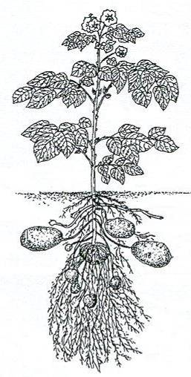
_____________________________________________________________________
________________________________________________

In the figure of the potato plant, draw arrows to show how the food stored in starch got to the potato.

5. When we eat plant parts, such as fruits and vegetables, we eat energy-rich food (starch and sugars) that the plants have made and stored. Did the plants make it for us? _______ (yes or no)

6. Why you think the plants make the energy-rich starch and sugars?
________________________________________________
_____________________________________________________________________
Name: __________________________________________ Date: ____________

How is food used in plants?

Each cell in each plant part uses glucose in two ways:
1. as a source of atoms for growing (making new molecules)
2. as a source of energy (for doing life’s processes)

The table below describes how much of a plant’s mass (in g) is made up of different molecules.
 | Apple fruit (100 g) | Peanut seeds (100 g) | Spinach leaves (100 g)
Water | 85.6 | 6.5 | 91.4
Carbohydrates | 13.8 | 16.1 | 3.6
Fats | 0.2 | 49.2 | 0.4
Proteins | 0.3 | 25.8 | 2.9
Other | 0.1 | 2.4 | 1.7

Using the table above, answer the following questions.
 | Apple fruit | Peanut seeds | Spinach leaves
What molecule makes up the most mass of the plant?
What types of atoms make up this molecule?
Where did the plant get these atoms?
How did these atoms get inside the plant?
What molecule makes up the next biggest amount of mass?
What types of atoms make up this molecule?
Where did the plant get these atoms?
How did these atoms get inside the plant?
The table below describes how much of a plant’s mass (in g) is made up of the different atoms of minerals from the soil. Notice that compared to the amount of a plant’s mass made up of water, fats, proteins, and carbohydrates the amount minerals is very small.

 | Apple fruit (100 g) | Peanut seeds (100 g) | Spinach leaves (100 g)
Calcium | 0.006 | 0.092 | 0.099
Iron | 0.0001 | 0.005 | 0.003
Magnesium | 0.005 | 0.168 | 0.079
Nitrogen | 0.048 | 4.128 | 0.464
Phosphorus | 0.011 | 0.376 | 0.049
Potassium | 0.107 | 0.705 | 0.558
Sodium | 0.001 | 0.018 | 0.079
Zinc | 0 | 0.003 | 0.001
Copper | 0 | 0.001 | 0.0001
Manganese | 0 | 0.002 | 0.001

As you have seen, plants cells are made of mostly water, fats, proteins, carbohydrates and some minerals.

When a plant grows bigger, what is happening inside the plant? When they grow, plants take the food they make, the simple sugar glucose, and use enzymes to build bigger molecules such as fats, proteins, and carbohydrates. These molecules are the building blocks for the new cells and organelles of the plant. Proteins and some other molecules require the atoms from minerals, such as calcium or nitrogen, to work properly. Therefore, even though plants get most of their mass by making food and taking up water from the soil, plants also need a small amount of nutrients from the soil.

- What do plants need energy to do?

- Where does this energy come from?

How do you think plants release this energy to use it to do work? To use the energy stored in food, plants break down food molecules in a process called cellular respiration. Breaking down the molecules releases the stored energy and allows plants to use it for work. This process is identical to the way you, dogs, mushrooms, and bees (and many, many other living things) use food for energy so it also requires oxygen.

Enzymes located in the cells of plants, break apart molecules of food and oxygen and change them into molecules of carbon dioxide and water. These are the same byproducts that animals make!

Cellular respiration is the process by which cells change (transform) the chemical potential energy found in energy-rich substances (food) into usable, motion energy and heat.

MATTER Glucose + Oxygen → Carbon dioxide + Water
ENERGY Chemical Potential Energy → Motion Energy + Heat

- After plants use food for energy, where do you think the carbon atoms in the food go?

- When plants break down food in cellular respiration, what happens to the chemical potential energy that was stored in the food?

- When plants use the glucose molecules they make in photosynthesis to build fats, carbohydrates, and proteins to grow, what happens to the chemical energy in those glucose molecules?

- Can the plant use these molecules as a food source later?

- Use the matter and energy process tools below to show how plants use the food they make (glucose) to large carbohydrate molecules.

Energy
Matter
Building large carbohydrate molecules
Growth

Energy
Matter
Energy
Matter
Using energy to build large molecules
Cellular Respiration

Energy
Matter

- Besides these two processes, what other kinds of things can plants use the sugar they make to do?
Now think back to the results of your radish experiment.

- Why did the radishes grown in the light and with water gain weight?

- Where did the weight come from?

- Was all the new weight glucose? If not, what other types of molecules do you think the radish plant made as it was growing?

- Why did radish seeds that were grown in the dark with water loose weight even as they sprouted and started to grow?

- Where did these seeds grown in the dark get their food?

- What happened to the weight that was lost?

- People frequently get confused about plants. They may think that plants and people are exact opposites—that people breathe in oxygen for their cells to work and plants “breathe” in carbon dioxide for their cells to work. They also think that plants “breathe out” oxygen for people to use. This is not the whole story! What would you say to a friend who believes this?

Name: __________________________________ Date: ____________ Period: _________
Telling a Starch Story
Work with your group to tell the story of a starch molecule. The starch molecule was in a potato (still growing and attached to a potato plant) yesterday and right now it is supplying the potato plant’s stem cells with energy to move sugar around. Tell a story that includes:

• What raw materials (matter) and energy source did the plant combine in order to make a starch molecule?
• What happened within in the leaves, stem, and roots of the potato plant to result in a starch molecule stored in the potato?
• What happened to the starch molecule when the plant needed to use the stored energy?
• What forms of matter and energy were left when the plant used the starch molecule?

You will need to complete this story in partners. Everyone should fill out the chart on the next page as best as you can. The lists below suggest what might go in each column for some key stages in the process. Do you think that you could trace what happens to the individual carbon, oxygen, and hydrogen atoms as they go through the entire process? Each group should also figure out an interesting way to tell the story that includes the essential information from the chart and share their story with the other groups.

Some important chemical processes include:  --photosynthesis  --biosynthesis  --cellular respiration | Some important forms of matter include:  --carbon dioxide  --oxygen  --water  --glucose  --starch | Some important forms of energy include:  --light energy  --chemical potential energy in C-C and C-H bonds  --heat energy | Some important locations include:  --air and soil  --leaf, stem, root and potato cells of potato plants

Starch Table (You may not need every row in the table)
Name of process | Change in matter (from --- to ---) | Change in form of energy (from --- to ---) | Change in location (from ---- to ----)

Plants Problem-Solving
- Many kinds of trees lose their leaves when it is very cold. However, many of the trees’ cells are still doing work all winter long. How do you think these trees survive in the winter?

- Some plants grow from bulbs, which is a food storage organ found beneath the soil. The amaryllis is one of these kinds of plants. Jonathan weighed an amaryllis bulb. He then weighed some soil and a pot. He planted the amaryllis bulb in the soil in the pot. He watered the amaryllis bulb regularly and kept it in a warm, bright room.
- What do you predict will happen to the amaryllis bulb?

- What do you predict will happen to the weight of the bulb of the amaryllis after a month? Will in increase or decrease? ________________Why do you think that?

- What do you predict will happen to the weight of the whole amaryllis plant after a month? Will in increase or decrease? ________________Why do you think that?

- What do you predict will happen to the weight of the soil after a month? Will it increase or decrease? ________________Why do you think that?

- The US National Oceanic and Atmospheric Administration (NOAA) collects atmospheric CO₂ levels from all over the world. Your teacher will show you a movie of the CO₂ levels in the atmosphere over the course of one year, 2008.

- When during the year is the amount of CO₂ in the atmosphere above the northern hemisphere (where most of the world's land is) the highest?

- When during the year is the amount of CO₂ above the northern hemisphere the lowest?

- With regards to plants’ functioning, what is different about those two parts of the year?

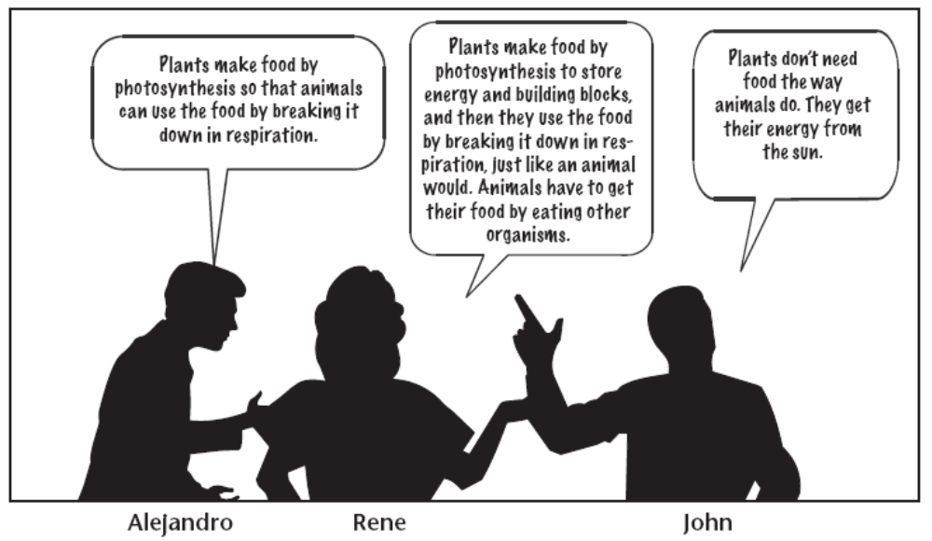
- Three students are discussing how plants and animals use food. Which student do you agree with? Explain your reasoning.

